G. Rupa Manasa 11-12-2023

Day 7 Assessment

**Data Cleaning**

The process of data cleaning (also called data cleansing) involves identifying any inaccuracies in a dataset and then fixing them.

It’s the first step in any analysis and it includes deleting data, updating data, and finding inconsistencies.

**Deleting the Duplicate Values**

* Checking which rows have duplicate values

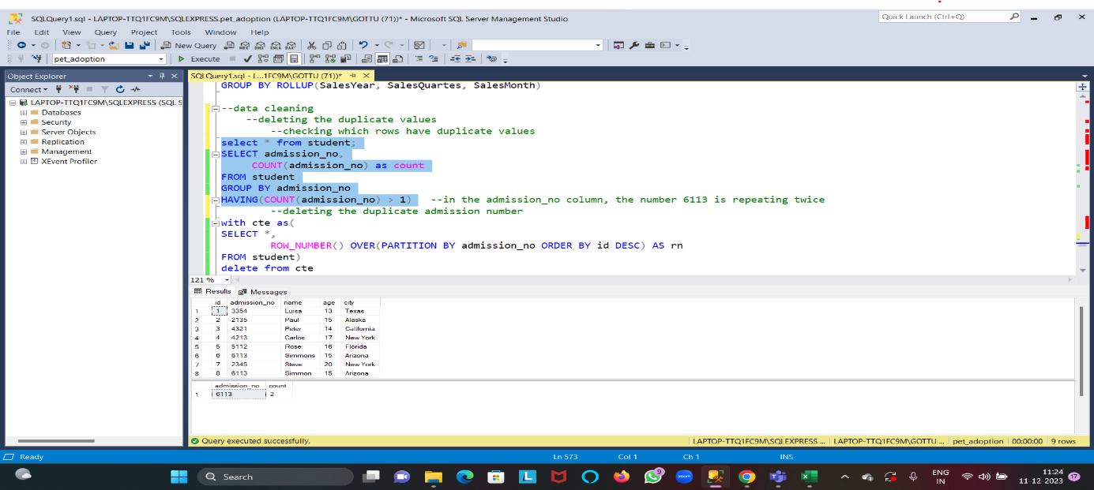

* Deleting the duplicate values

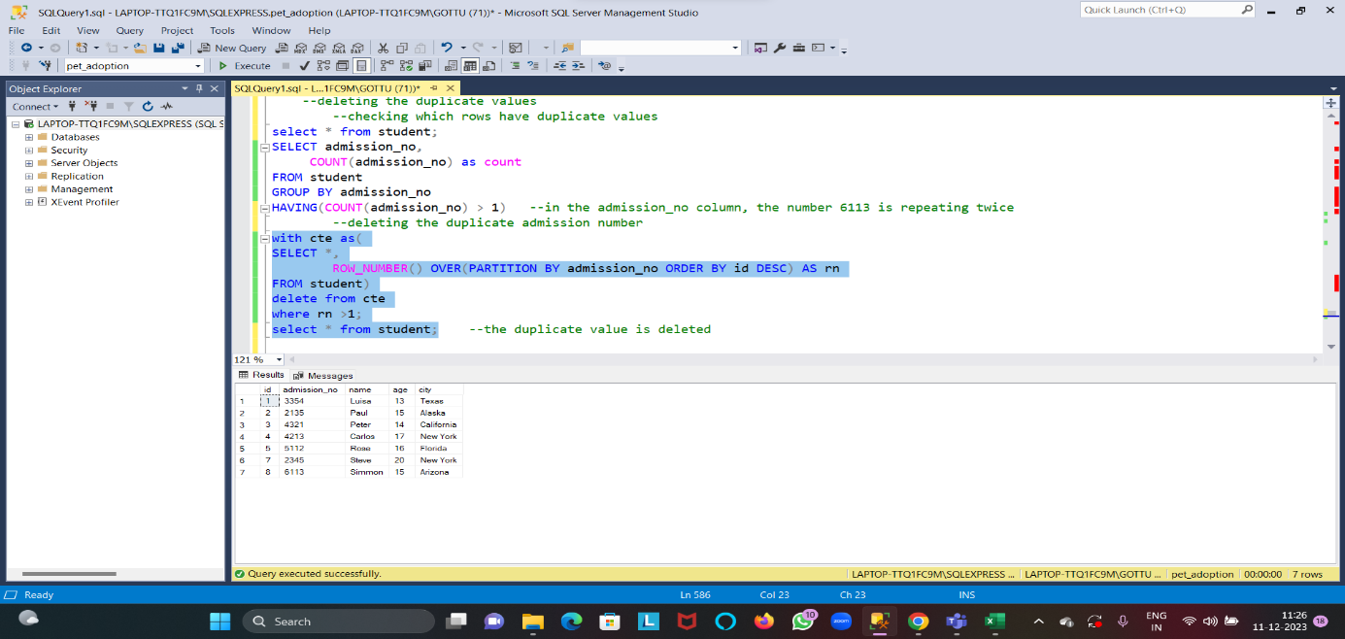

* Deleting duplicate value using distinct

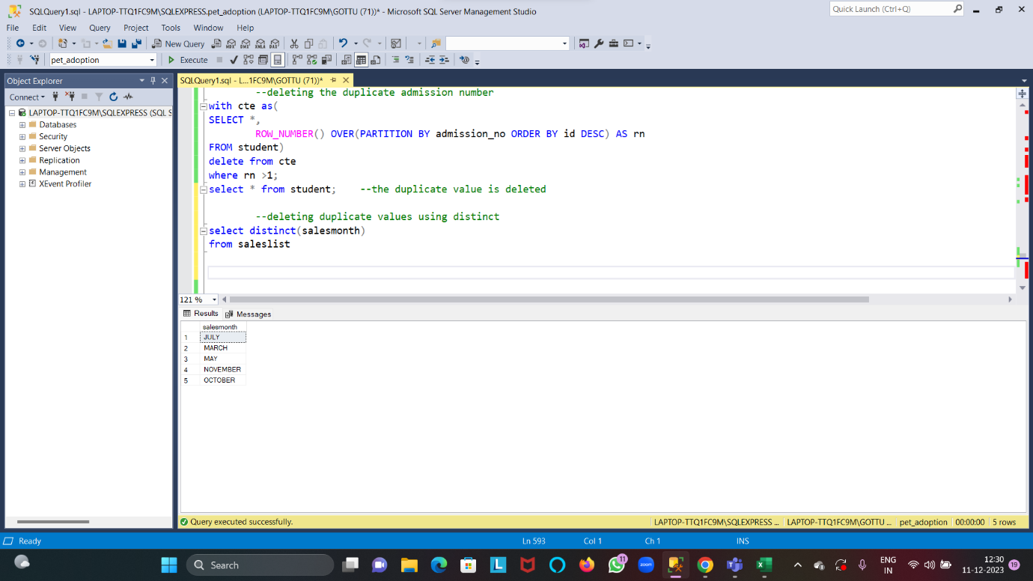

**Removing Null Values**

* Checking which column or row have null values.

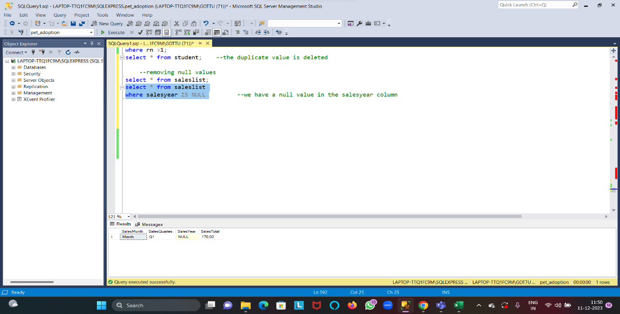

* Removing null value and updating the value

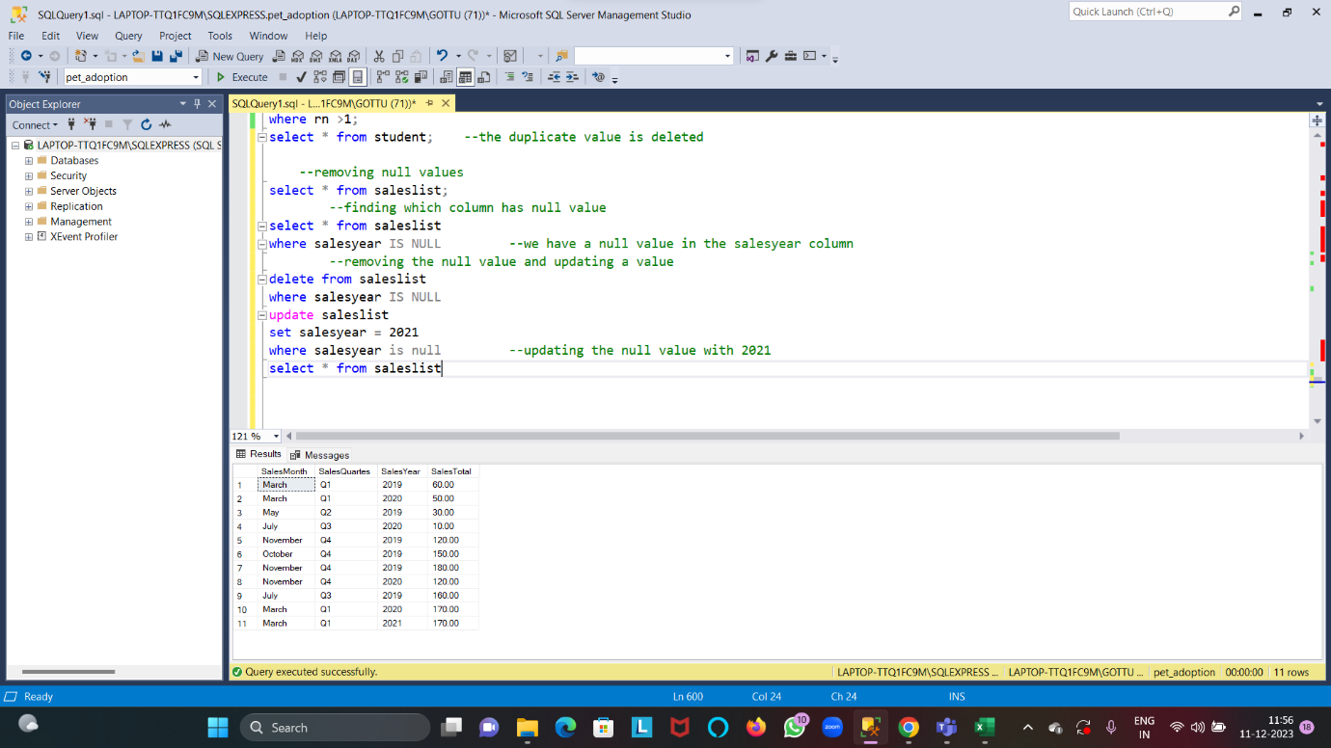

**Standardizing and transforming data**

* Capitalizing

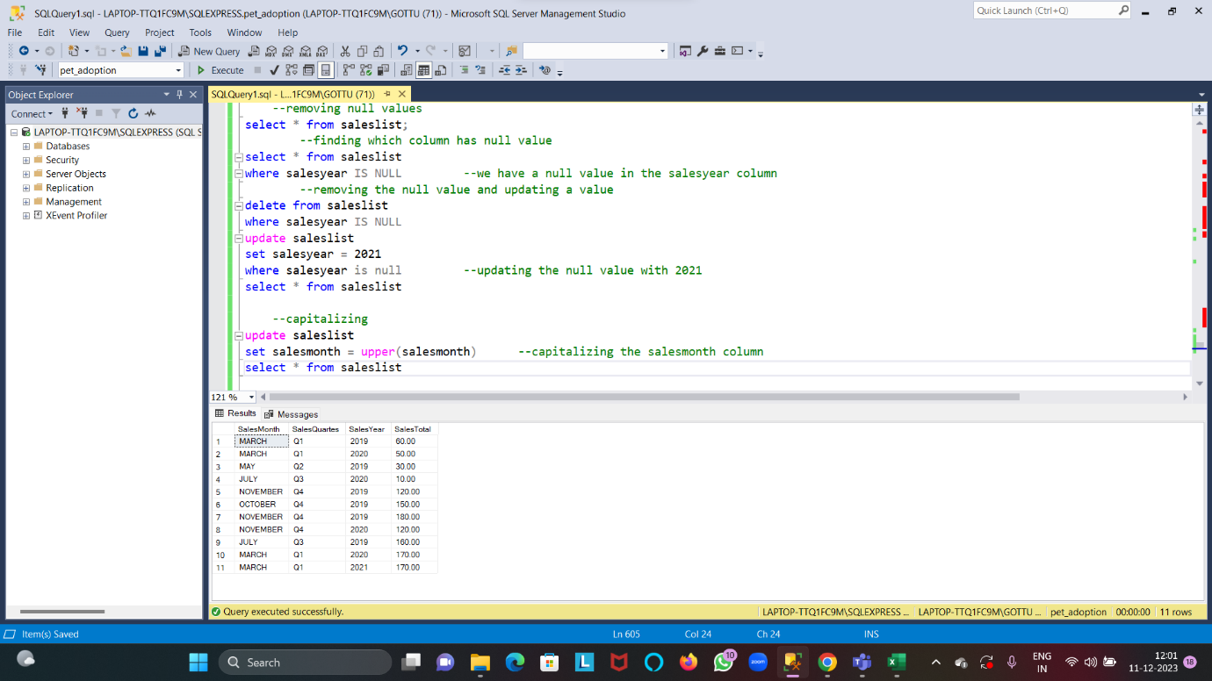

* Converting to lower case

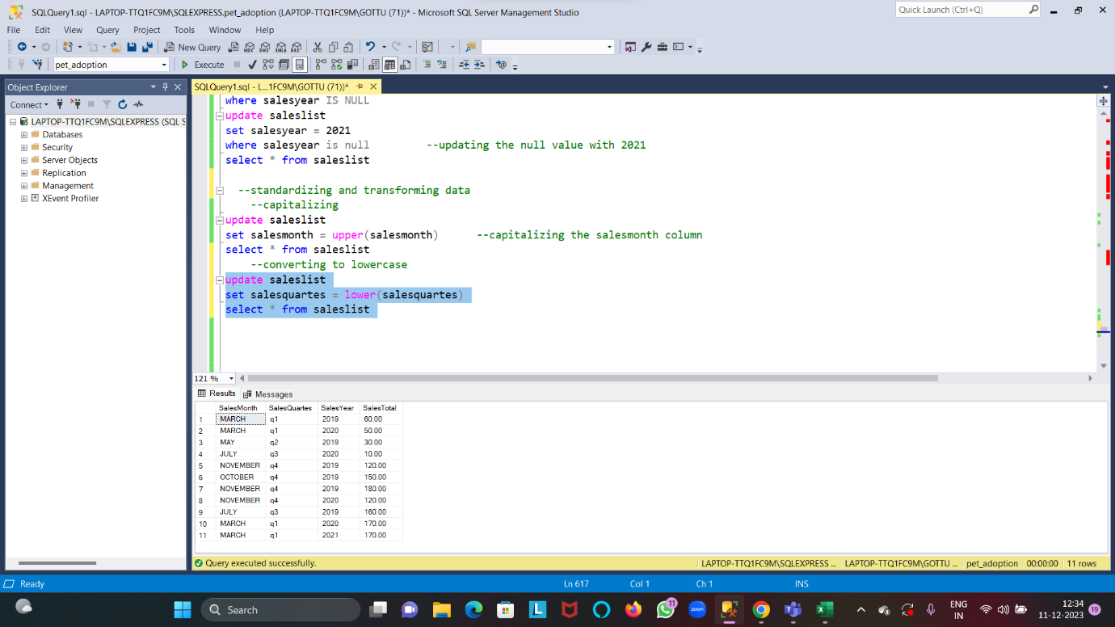

**Trim**

Removing leading and trailing spaces if any

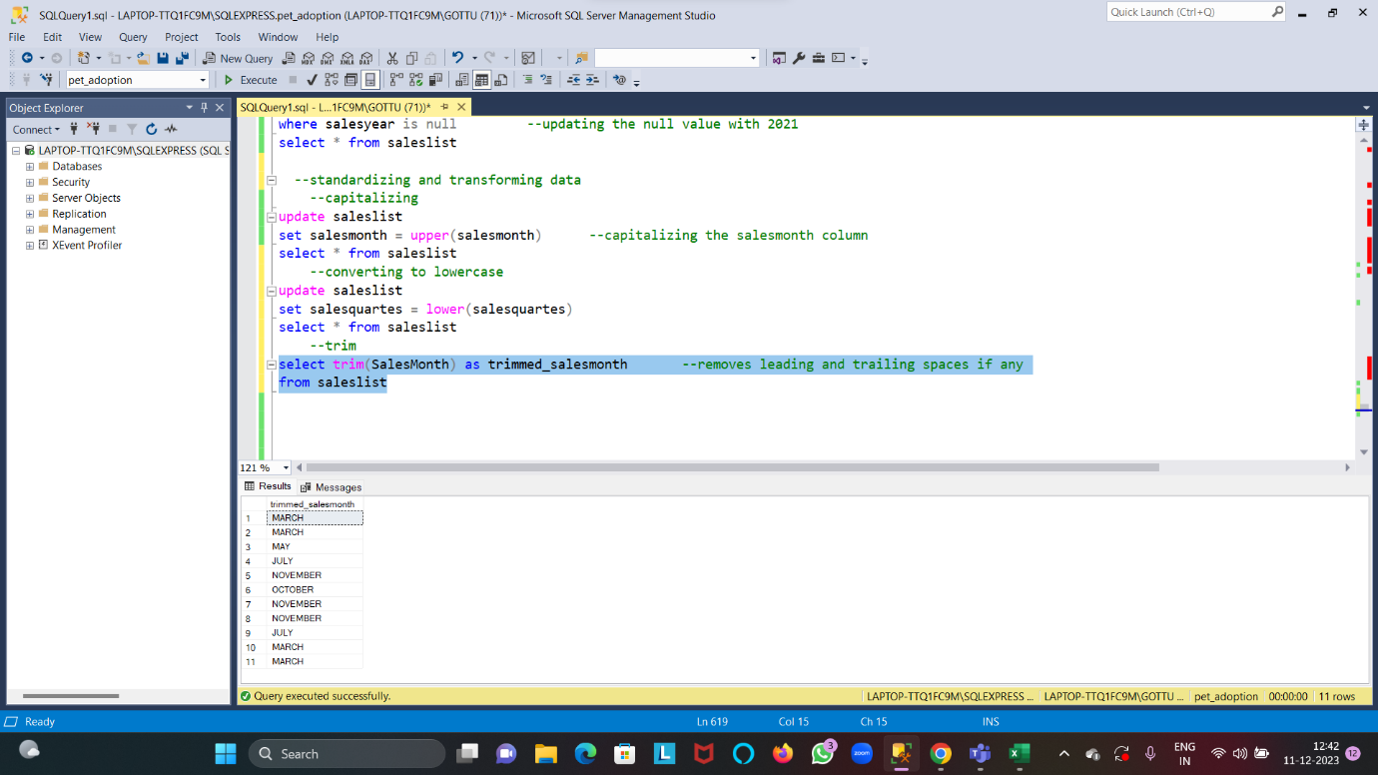

**Partition By clause**

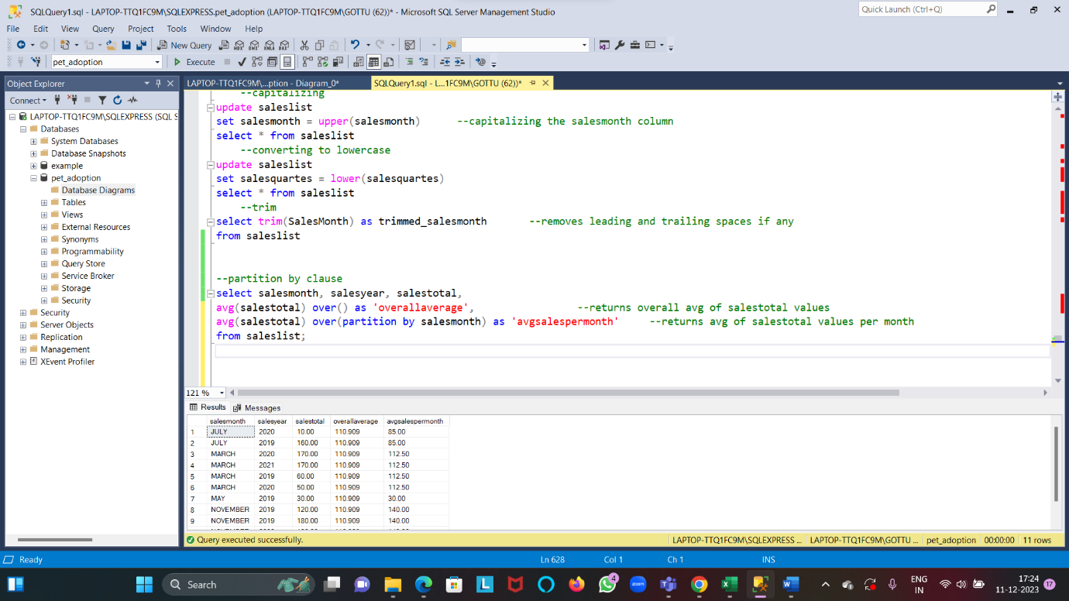

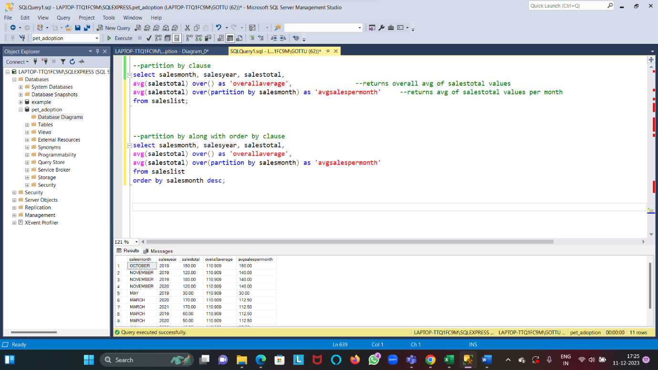

**Schema Diagram**

